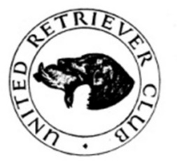
URC MIDLAND AREA
(Kennel Club ID No 712)
ALL AGED (unclassified) TEST
RUN ON FIELD TRIAL LINES USING DUMMIES
WALKED UP IN FODDER BEET
Limited to 30 dogs
SATURDAY 9th AUGUST
by kind permission of Mr David Knight
Near Cransley, Kettering

(MEET 9.00 AM FOR A PROMPT 9.30 START)
Judges: Godfrey Lowe A2696, Reuben Mort B2977, Andrew Sweeney NP
& Charlotte Wilkinson NP5013
Steward: Maurice Fitch
The Silver Plate for the Winner
The Charlesworth Cup for the Best Retrieve of the Day

Entry Fee £15, Entries Close on Friday 1st August, Draw Monday 4th August
Entry by FTMS or paper entries accepted

DO NOT PAY ENTRY FEE UNTIL THE DRAW HAS TAKEN PLACE
There will be a raffle so prizes would be appreciated
All working tests are run under Kennel Club Rules and Regulations. Please remember when you sign an entry form you agree to be bound by these, have you read them? Copies may be purchased from the Kennel Club.

All dogs must be registered at the Kennel Club and all owners(single or joint) must be fully paid up members of the URC.
No in season bitches to be brought onto the ground.

Working Test Secretary Jane Samson 07721 070070 jane.urcmidland@gmail.com
Chief Steward Maurice Fitch 07860 532547 (on the day only)

