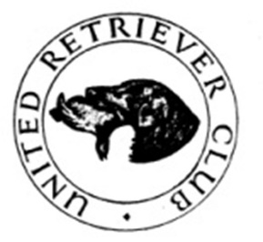
URC MIDLAND AREA
NOVICE TEST
SUNDAY 10TH MARCH 2024 At Marston Lodge, Marston Trussell near Market Harborough
(MEET 9.00 FOR A PROMPT 9.30 START)
by kind permission of Patrick and Charlotte Clackson and their Manager Chris Thresh
Judges: Sally Richardson A3214, Godfrey Lowe A2696, Becky Thistle NP4076 & Phil Robinson NP
Steward: Maurice Fitch
TROPHIES
The Midland Area Novice Cup to the winner
The Streamrise Sally-Ann Trophy to the highest placed Golden Retriever
which must appear in the awards
Entry Fee £15 Entries Close on Sunday 3rd March Draw 4th March
Entry by FTMS enter and pay or paper entries accepted
If oversubscribed there will be a draw
There will also be a raffle so prizes would be appreciated.
WORKING TEST NOTES
QUALIFICATION: Any dog or bitch which has not received a 1st, 2nd, 3rd or Reserve in an Open Test
or a 1st in a Novice or All Aged Test or any Field Trial Award
All working tests are run under Kennel Club Rules and Regulations. Please remember when you sign an entry form you agree to be bound by these, have you read them? Copies may be purchased from the Kennel Club. All dogs must be registered at the Kennel Club and all owners (single or joint) must be fully paid up members of the URC. No in season bitches to be brought onto the ground. It is the responsibility of the winners of trophies to get them engraved.
Directions: LE16 9TY will take you to the church where signs will be out. What3words for the Lodge is prime.snuggled.shortens
Kindly Sponsored By


Acting Working Test Secretary Jane Samson 07721 070070
Chief Steward Maurice Fitch 07860 532547 (on the day only)

