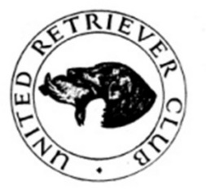
URC MIDLAND AREA
OPEN TEST WITH INTERMEDIATE AWARD
SATURDAY 9^{H} MARCH 2024 At Marston Lodge, Marston Trussell near Market Harborough
(MEET 9.00 AM FOR A PROMPT 9.30 START)
by kind permission of Patrick and Charlotte Clackson and their Manager Chris Thresh
First and Second will be invited to attend the selection day for the England Retriever Team
The team for the URC Area finals will be chosen from the three highest placed Midland Area Members
Judges: Laura Hill A3229, Sam Morley-Riches A3103, Nicola Reynolds A3574 & David Brown A3357
Steward: Maurice Fitch
TROPHIES
The Midland Area Open Cup
The Braeduke Cup to the highest placed Yellow Labrador
The Clancallum Shield to the highest placed Golden Retriever
The Wagtail Misty Trophy to the highest placed Black Labrador
(the above dogs must feature in the awards)
The Intermediate Rosebowl to the highest placed Intermediate Dog
Entry Fee £15 Entries Close on Sunday 3rd March Draw 4th March
Entry by FTMS enter and pay or paper entries accepted. If oversubscribed there will be a draw
There will also be a raffle so prizes would be appreciated
WORKING TEST NOTES
Open Test is Open to All
Intermediate Qualification: any dog or bitch not having won
a) a 1st in any INTERMEDIATE, OPEN OR ALL-AGED WORKING TEST
b) A 1ST, 2ND or 3rd in any Field Trial
All working tests are run under Kennel Club Rules and Regulations. Please remember when you sign an entry form you agree to be bound by these, have you read them? Copies may be purchased from the Kennel Club. All dogs must be registered at the Kennel Club and all owners (single or joint) must be fully paid up members of the URC. No in season bitches to be brought onto the ground. It is the responsibility of the winners of trophies to get them engraved.
Directions: LE16 9TY will take you to the church where signs will be out. What3words for the Lodge is prime.snuggled.shortens
Kindly Sponsored By
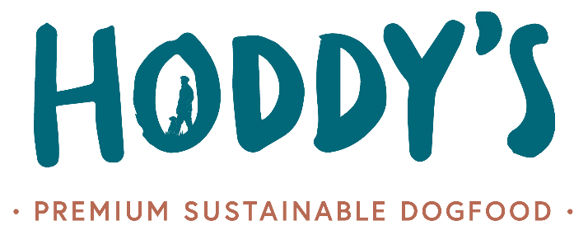

Working Test Secretary Jane Samson 07721 070070: Chief Steward Maurice Fitch 07860 532547 (on the day only)

